|  |
| --- |
| **AJAY THAPA** |

**OBJECTIVE**

|  |
| --- |
| **My Objective is to learn and continuously develop my professional work orientation and managing skills so as to become a sound professional in corporate sphere and work enthusiastically with a team to achieve the desired goals of the organization with devotion.** |

**PROFESSIONAL QUALIFICATION**

* **Appeared MBA (Marketing Management) from**

**Darwin School of Business, Guwahati.**

* **Certificate course in Retail Banking & Management From ICICI Sales Academy, ITM Noida.**

**ACADEMIC QUALIFICATION**

* **Passed B. Sc (Zoology) from Dibru College, Dibrugarh under Dibrugarh University 2010.**
* **Passed H.S. (Science) from Jonai H.S. School, Jonai in 2006.**
* **Passed H.S.L.C. from Jubilee Model High School in 2004.**

**PROJECTS DONE**

* **Worked for Career Cliniq giving workshop on “Management as Career” in various schools of Jonai.**
* **Worked under Byatikram MASDO (Byatikram Mass Awareness & Social Development Organization) Cholo Kolkata (an admission campaign & career mela) in Silchar.**
* **Volunteered for American Center, programs in Guwahati “Experience America”.**
* **Volunteered on a “Runway” organized by Assam Foundation of North America.**
* **Recently completed a project under Career Track EDU YEAR BOOK in Sales & Marketing in North East.**

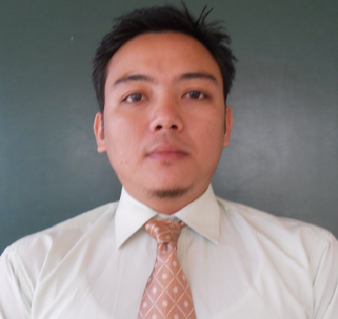

**Mobile:** +91-7308127756

binaajaythapa098765@gmail.com

**PERMANENT ADDRESS:**

Vill- Lakhi Nepali Basti

P.O.- Jonai

Dist- Dhemaji, Assam

Pin: - 787060

**PERSONAL INFORMATION:**

DOB: - 10/10/1988

Father’s Name: - Krishna Br Thapa

Mother’s Name: - Bina Thapa

**LANGUAGE PROFICIENCY:** English, Hindi, Assamese and Nepali.

**STRENGTHS:**

Punctual, Smartly Hardworking, Discipline and Sincerity.

**HOBBIES AND INTEREST:**

Visiting new places, Playing football.

**TECHNICAL QUALIFICATION**

* **Diploma in Computer Application (DCA) MICE.**

**WORK EXPERIENCE**

* **Working at ICICI Bank Ltd. Itanagar Branch as Sales officer . Date of Join- 27th January 2014 till date.**
* **Winner of the contest namely “Call of Victory October 2014” organize by ICIC Bank Ltd.**

**KEY RESPONSIBILITY**

* **Deals in CASA**
* **Life Insurance & Mutual Funds**
* **SIP & All Cross sell products**
* **Maintaining DSR on Daily basis**

**WORKSHOP AND SEMINAR ATTENDED**

* **a Workshop on “Management as Career” organized by “Career Cliniq”.**
* **A Workshop on “Disaster Management” organized by “Assam Disaster Management Development Authority”.**
* **a Seminar on “Dream and Aspiration Building Blocks**

**for Youth Development”.**

* **Leadership training program organized by Foundation for Social Transformation (FST).**

.

**DECLARATION**

***I hereby declare that all the above mentioned information is true and correct to the best of my knowledge.***

**Date: Ajay Thapa**